Objective list theories believe in objective prudential goods: that is, being a couch potato can bring joy, but only experiencing virtuous activities can bring happiness(Haybron, 2020). Nevertheless, individuals still have subjective understandings of objective goods. For instance, perfectionism believes perfecting human nature constitutes one's happiness (Crisp, 2017), and Aristotelians believe achieving eudaimonia needs the fulfillment of human capacities (Haybron, 2020).
However, whether one approaches from the objective or subjective line of investigation, happiness cannot be measured. That is because the two necessary processes involved in measurement are impossible to be satisfied, which are:
I. Respondents have a clear understanding of their personal happiness (I - inner)
II. They convey their sense of happiness accurately and completely to the test (inner-outer)
The following essay will illustrate why the two processes cannot be satisfied, and therefore support the claim.
The process I: Realization of the self
Lao-Tzu believes that "He who knows himself is enlightened (Laozi, 2018)." Knowing oneself is fully discovering one's feelings, thoughts, and beliefs (Gertler, 2020). Since happiness is subjectively perceived as forms above, one first needs to understand what is his/her knowing, or at least what makes him/her approach knowing. With this benchmark, one can then evaluate how far is he/she away from knowing.
Because happiness blends inseparably with physical sensation, one's knowledge of externality will first affect knowing. To learn the external world, Locke writes, "Tis therefore the actual receiving the ideas from without that gives us notice of the existence of other things (Rockwood, 2018)." That means the knowledge about externality doesn't build from established beliefs toward externality but is from our raw sensation. To discern these two sources, individuals' perception needs to be a "dynamic searching for the best interpretation of available data" (Gregory, 2015), and I interpret this search as self-consciousness.
Being self-conscious takes two steps. By invoking system II ¹, individuals first direct their attention to effortful mental activities and once autopilot behaviors, providing a threshold for gaining subjective experiences (Kahneman, 2011). Nearly simultaneously, metacognition involves monitoring one's cognitive states, ensuring individuals view their thoughts critically. System II and metacognition push an individual to the boundary of known, and the process of taking the unknown into the known is self-conscious.
However, barriers hinder human beings from discovering the self. Biologically speaking, human beings have a natural tendency to conserve energy and thus evade the activation of System II, especially on tasks that can be done with System I ² (Kahneman, 2011). Moreover, individuals can fail to realize that their attention to externality is virtually divided. As Corteen and Wood (1972) discovered, when words didn't consciously perceive by participants, they still established meaning in their minds. With all barriers to realizing the self, Kants says a man cannot "determine with certainty what would make him truly happy; because to do so he would need to be omniscient (Kant, 1889)."
The idea of being omniscient is to transcend and discover one's essential state of happiness. However, even if a being believes he/she attains a sense of happiness, it may be a fallacy and not the knowing. To illustrate this claim, I adopt Tal Ben-Shahar's (2007) model and analyze possible cognitive limitations hindering each archetype's transcendence. Every individual who forms a belief to present and future happiness can fill into a quadrant.
Figure 1
The four quadrant ³
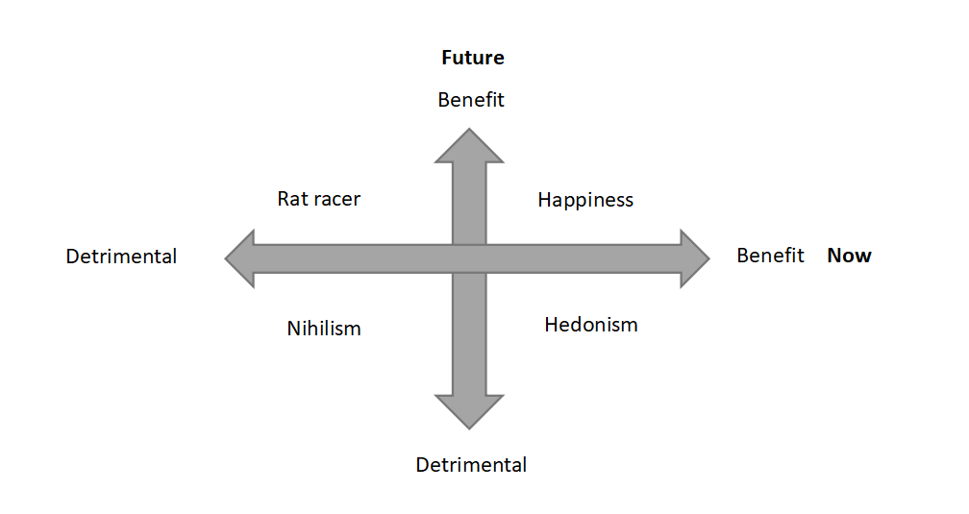
Hedonism: Ultimate happiness is attained
By taking psychoactive drugs and performing religious behaviors, human beings can intentionally alter their states of consciousness (Cacioppo & Freberg, 2019). With this artificial change of beliefs, hedonistic drug takers regard instant satisfaction as happiness and disregard their future. However, if happiness exists in the form of eudaimonia, the overall achievement in life is related to one's level of happiness (Warburton, 2012). Since hedonists blind future possible happiness, transcendence can only occur when they realize the mistake of regarding instant excitement as ultimate happiness.
Nihilism: Happiness died
During World War II, numerous people failed into learned helplessness and believed they lost both present and future happiness. According to Karl Jasper's theory, they fail into a "limit situation," believing that only the external locus of control exists (Valdes-Stauber, 2016). However, a "limit situation" can "becomes one's destination in the realization of one's existence," provoking people to ask for higher happiness (Jacobsen, 2008). Frankl (2006) accepted his unavoidable sufferings bravely, believing meaning is inherent in experiences. People with severe chronic diseases learn to adapt to their impairments and transcend themselves (Charmaz, 1995). Thus, if the higher happiness integrates the meaning of pain, nihilists evaluate their happiness based on their "existence" rather than their "essence" (Sartre, 1946), disregarding the potential of transitoriness.
Happiness: the distinction between evaluation and beliefs
Happiness is the archetype with the highest possibility of approaching the knowing since they believe they can discover one's maxim of happiness for now and the future. With the belief to transcend, they take happiness more as a dynamic skill that detaches from established experience. However, if the perception turns to an explicit rating within oneself, possible bias may occur while constructing the frame. For instance, about what contributes to one's happiness, individuals take certain aspects as the primary cause, but the ignored intricate associations among these aspects are also essential for gaining happiness. As gestalt psychology illustrated, one's understanding "seems to depend upon relations among the stimuli rather than upon the individual stimuli as such (Kohler, 1967)." Therefore, the transition between perception and evaluation can undermine the known.
Rat Racer: Serving for happiness
Rat racers "subordinate the present to the future" and "suffer now for some anticipated gain" (Tal Ben-Shahar, 2007), regarding their sacrifice in present happiness is meaningful. However, this destiny-orientated pursuit ignores the impact of the shift in reference points. Under this "finite game" (Carse, 2012), rat racers keep aiming for a higher reference point and leave themselves in a state of loss. Due to loss aversion, the same amount of gain from the past and loss from now cannot subjectively offset each other (Kahneman, 2011). Without possible transcending, which is to gain happiness from journeys, rat racers accumulate their loss and search for happiness continuously with improper direction.
Figure 2
The utility function ⁵
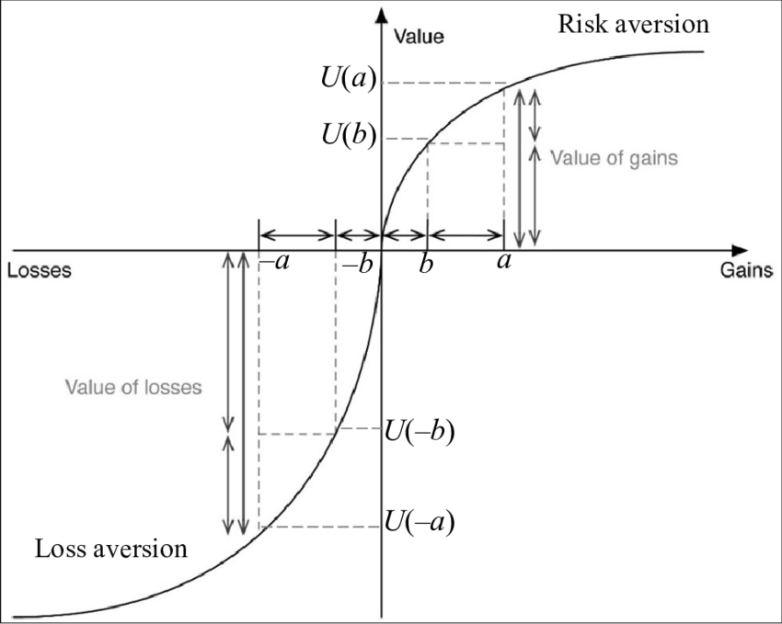
Overall, because of the difficulty of approaching knowing and one’s cognitive limitation, the first process is nearly impossible to be achieved.
The process II: The interaction between internality and externality
Now the respondents need to convey their understanding to the test. Two conditions are needed to satisfy process II:
Condition I: Individuals are willing to convey their understanding of externality fully and accurately
Condition II: Externality constructs a frame that can capture individuals' understanding comprehensively
Firstly, for Condition I, tests' intention strongly affects individuals' willingness. If the test aims to achieve the externality's purpose, such as collecting data for scientific research, moderate anonymity facilitates authenticity by lowering social desirability pressures (Lelkes et al., 2012). However, if the respondents regard the measurement as a way of knowing themselves, one essential question arises: Can a man be honest to himself when he/she stays alone?
The existence of cognitive dissonance undermines respondents' willingness to convey their understanding. For rat racers, reporting "happy" (action) allows respondents to stay consistent with the social expectation of wealth and fame (belief), even though they realize the lack of happiness. Moreover, under the value system that "unhappiness is a symptom of maladjustment" (Frankl, 2006), respondents may hide their willingness further to conform to social desirability and reduce their cognitive dissonance.
Secondly, an effective frame should first capture all respondents' understandings to satisfy Condition II. Therefore, researchers use "meaning" in tests without clarification or a broad definition such as "as the sense made of" (Steger et al., 2006). However, the lack of precision means respondents' understanding must be clear. If Process I fails, then Condition II will be hard to achieve.
Alternatively, the test can be more precise by including potential factors, such as "non-hedonic sources of happiness and suffering (Stone et al.,2013)." Nevertheless, precision can bring more challenges. For instance, overcoming challenges can bring competence, which is normally regarded as a promoter of happiness. But competence cannot enhance their happiness if respondents feel a lack of autonomy while handling the tasks (Ryan & Deci, 2000). Therefore, if the measurement improves the evaluation by incorporating more correlated sources, such as competence, it should take even more correlated factors to ensure the test is unbiased.
Not only does the trade-off between broadness and precision bring a challenge, but the cognition of society also limits the frame of the test. Influenced by culture, measurement in a collectivist society attaches more importance to contributions toward groups, likely to regard these efforts are more eudaimonic than personal growth. Influenced by the features of an era, society's understanding of happiness diverges with individuals'. For instance, in Song Dynasty, Su Tungpo spoke truth to power and thus was exiled to undeveloped land such as Lingnan. Even though he suffered, he still perceived a strong sense of happiness, expressing that in his poem: "With three hundred litchis every day and night; I am willing to be a Lingnan man for the rest of my life (Lin, 2018).” Society aims to suppress him and reduce his happiness, but Tungpo "amor fati"--loves his fate (Han-Pile, 2009). The diverged understandings between individual and externality mean that if the externality constructs a measurement, it would hardly be not biased.
More importantly, it is hard for individuals to realize that society and themselves have diverged understanding toward happiness. For instance, it is convincing that social connection can promote the development of self-esteem (Maslow, 1943), but is it possible that society overly reinforces the role of externality on one's happiness? Under the encouragement of social networks, individuals may falsely regard solitude as loneliness, internalizing society’s value and veiling their personal understandings. Society believes tests such as subjective well-being shows strong convergent validity (Stone et al., 2013), but is this testing individuals' subjective well-being? Or it is more about society-encouraged well-being?
Conclusion
This essay argues that happiness cannot be measured by examining two processes.
First, an individual must approach knowing to establish a benchmark for subjective measurement. However, staying self-conscious is arduous; additionally, possible cognitive limitations of hedonism, nihilism, and rat racer, and conversion from beliefs to evaluation for happiness archetype can hinder the process of knowing. Thus, the process I cannot be satisfied with.
Second, respondents' willingness to convey and the test's frame determine the effectiveness of process II. Respectively, cognitive dissonance undermines one's willingness to convey, and the trade-off between broadness and preciseness brings challenges to constructing the frame. Moreover, since society's cognition limits the test frame significantly, individuals' understandings to happiness are hard to be reflected. If the test is constructed by externality, it will continuously measure socially desired well-being rather than subjective well-being.

References
Cacioppo, J. T., & Freberg, L. (2019). Discovering psychology 3e : the science of mind. Cengage.
Carse, J. P. (2012). Finite and infinite games : a vision of life as play and possibility. Free Press.
Charmaz, K. (1995). The Body, Identity, and Self: Adapting to Impairment. The Sociological Quarterly, 36(4), 657–680. https://www.jstor.org/stable/4121346
Corteen, R. S., & Wood, B. (1972). Autonomic responses to shock-associated words in an unattended channel. Journal of Experimental Psychology, 94(3), 308–313. https://doi.org/10.1037/h0032759
Crisp, R. (2017). Well-Being (Stanford Encyclopedia of Philosophy). Stanford.edu. https://plato.stanford.edu/entries/well-being/#ObjLisThe
Frankl, V. E. (2006). Man’s Search for Meaning. Beacon Press.
Gertler, B. (2020). Self-Knowledge (E. N. Zalta, Ed.). Stanford Encyclopedia of Philosophy; Metaphysics Research Lab, Stanford University. https://plato.stanford.edu/entries/self-knowledge/
Gregory, R. L. (2015). Eye and Brain : The Psychology of Seeing - Fifth Edition. Princeton University Press.
Han-Pile, B. (2009). Nietzsche and Amor Fati. European Journal of Philosophy, 19(2), 224–261. https://doi.org/10.1111/j.1468-0378.2009.00380.x
Haybron, D. (2020). Happiness (E. N. Zalta, Ed.). Stanford Encyclopedia of Philosophy; Metaphysics Research Lab, Stanford University. https://plato.stanford.edu/entries/happiness/#HedVerEmoSta
Jacobsen, B. (2007). Invitation to existential psychology : a psychology for the unique human being and its applications in therapy. John Wiley.
Kahneman, D. (2011). Thinking, Fast and Slow. Farrar, Straus and Giroux.
Kant, I. (1889). Foundations of the Metaphysics of Morals. http://www.sophia-project.org/uploads/1/3/9/5/13955288/kant_foundations.pdf
Khalil, T. E., Albastaki, F., Obaid, L., Zaid, H. A., Dalalah, D., & Alhassani, S. (2022). Ranking Risk Attitudes Using an Integrated AHP-TOPSIS Approach. International Journal of Applied Decision Sciences, 1(1), 1. https://doi.org/10.1504/ijads.2022.10037216
Kohler, W. (1967). Gestalt psychology. Psychologische Forschung, 31(1), XVIII–XXX. https://doi.org/10.1007/bf00422382
Laozi. (2018). Laws divine and human (Y. Xu, Trans.). Zhonghua Book Company.
Lelkes, Y., Krosnick, J. A., Marx, D. M., Judd, C. M., & Park, B. (2012). Complete anonymity compromises the accuracy of self-reports. Journal of Experimental Social Psychology, 48(6), 1291–1299. https://doi.org/10.1016/j.jesp.2012.07.002
Maslow, A. H. (1943). A Theory of Human Motivation. Psychological Review, 50(4), 370–396.
Rockwood, N. (2018). LOCKE ON EMPIRICAL KNOWLEDGE. History of Philosophy Quarterly, 35(4), 317–336. https://doi.org/10.2307/48570921
Ryan, R. M., & Deci, E. L. (2000). Self-Determination Theory and the Facilitation of Intrinsic Motivation, Social Development, and Well-Being. American Psychologist, 55(1), 68–78.
Sartre, J.-P. (1946). Existentialism is a humanism . Yale University Press.
Schumacher, E. F. (1978). A guide for the perplexed. Harper & Row.
Steger, M. F., Frazier, P., Oishi, S., & Kaler, M. (2006). The meaning in life questionnaire: Assessing the presence of and search for meaning in life. Journal of Counseling Psychology, 53(1), 80–93. https://doi.org/10.1037/0022-0167.53.1.80
Stone, A. A., Mackie, C. J., Policy-Relevant, I. A., & National Research Council (U.S.). Committee On National Statistics. (2013). Subjective well-being : measuring happiness, suffering, and other dimensions of experience. The National Academies Press.
Tal Ben-Shahar. (2007). Happier : learn the secrets to daily joy and lasting fulfillment. Mcgraw-Hill.
Valdes-Stauber, J. (2016). [Man at the Frontier of his Being: Scope of the Concept of “Limit Situation” in Psychiatry and Psychotherapy Following Jaspers’ Existential Ontology]. Fortschritte Der Neurologie-Psychiatrie, 84(1), 19–27. https://doi.org/10.1055/s-0042-101167
Warburton, N. (2012). A little history of philosophy. Yale University Press.
Yutang Lin. (2018). The Gay Genius：The Life and Times of Su Tungpo. Hunan Literature and Art Publishing House.

Footnotes
¹ According to Kahnman (2011), system II in mind “allocates attention to the effortful mental activities that demand it.”
²According to Kahnman (2011), system I in mind “ operates automatically and quickly, with little or no effort and no sense of voluntary control.”
³ The image is from Tal Ben-Shahar. (2007). Happier : learn the secrets to daily joy and lasting fulfillment. Mcgraw-Hill.
⁴ According to Carse (2012), finite game is “played for the purpose of winning”; oppositely, an infinite game is “for the purpose of continuing the play.”
⁵ The absolute value of U(-a) is greater than U(a), which means the subjective gain obtained from (a+b) cannot offset the subjective loss brought by -(a+b). This figure is from Khalil, T. E., Albastaki, F., Obaid, L., Zaid, H. A., Dalalah, D., & Alhassani, S. (2022). Ranking Risk Attitudes Using an Integrated AHP-TOPSIS Approach. International Journal of Applied Decision Sciences, 1(1), 1. https://doi.org/10.1504/ijads.2022.10037216.

